Python
Advanced Features & Ecosystem

Decorators • Generators • Async/Await • Context Managers • Dunder Methods
Duck Typing • Metaprogramming • GIL • Testing • Data Science Ecosystem
2026 Edition

Table of Contents

1. Advanced Language Features
Python offers powerful features beyond the basics that enable expressive, concise, and high-performance code. This chapter covers the most important advanced constructs.

1.1 Comprehensions
# List comprehension
squares = [x**2 for x in range(10) if x % 2 == 0]

# Dict comprehension
word_lengths = {w: len(w) for w in ['hello', 'world', 'python']}

# Set comprehension
unique_lengths = {len(w) for w in words}

# Nested comprehension (matrix flatten)
flat = [x for row in matrix for x in row]

# Generator expression (lazy, memory-efficient)
total = sum(x**2 for x in range(1_000_000)) # no list created

1.2 Unpacking & Starred Expressions
# Extended unpacking
first, *middle, last = [1, 2, 3, 4, 5] # middle = [2, 3, 4]

# Dict merging (Python 3.9+)
merged = {**defaults, **user_config} # user_config overrides
merged = defaults | user_config # same, cleaner

# Function argument unpacking
def greet(name, age): ...
data = {'name': 'Alice', 'age': 30}
greet(**data) # equivalent to greet(name='Alice', age=30)

1.3 Walrus Operator (:=)
The walrus operator assigns a value to a variable as part of an expression (Python 3.8+).
# Avoid calling expensive function twice
if (n := len(data)) > 100:
print(f'Too long: {n} items')

# In while loops
while chunk := file.read(8192):
process(chunk)

# In list comprehensions
results = [y for x in data if (y := transform(x)) is not None]

1.4 Structural Pattern Matching (match/case)
Python 3.10+ introduced match/case for powerful pattern matching with destructuring.
match command:
case {'action': 'buy', 'item': item, 'qty': int(qty)}:
buy(item, qty)
case {'action': 'sell', 'item': item}:
sell(item)
case {'action': action}:
print(f'Unknown action: {action}')

# With guards
match point:
case Point(x, y) if x == y:
print('On diagonal')
case Point(x, y):
print(f'({x}, {y})')

1.5 Slots, Dataclasses & NamedTuples
from dataclasses import dataclass, field

@dataclass(frozen=True, slots=True) # immutable + memory-efficient
class Point:
x: float
y: float
label: str = 'origin'
tags: list[str] = field(default_factory=list)

@property
def distance(self) -> float:
return (self.x**2 + self.y**2) ** 0.5

# NamedTuple (lighter alternative)
from typing import NamedTuple
class Color(NamedTuple):
r: int
g: int
b: int

slots=True
Adding slots=True to dataclasses (Python 3.10+) uses __slots__ instead of __dict__, reducing memory by 30-40% per instance and speeding up attribute access.

2. Decorators
A decorator is a function that takes another function and returns a modified version. They are the primary mechanism for cross-cutting concerns like logging, caching, authentication, and timing.

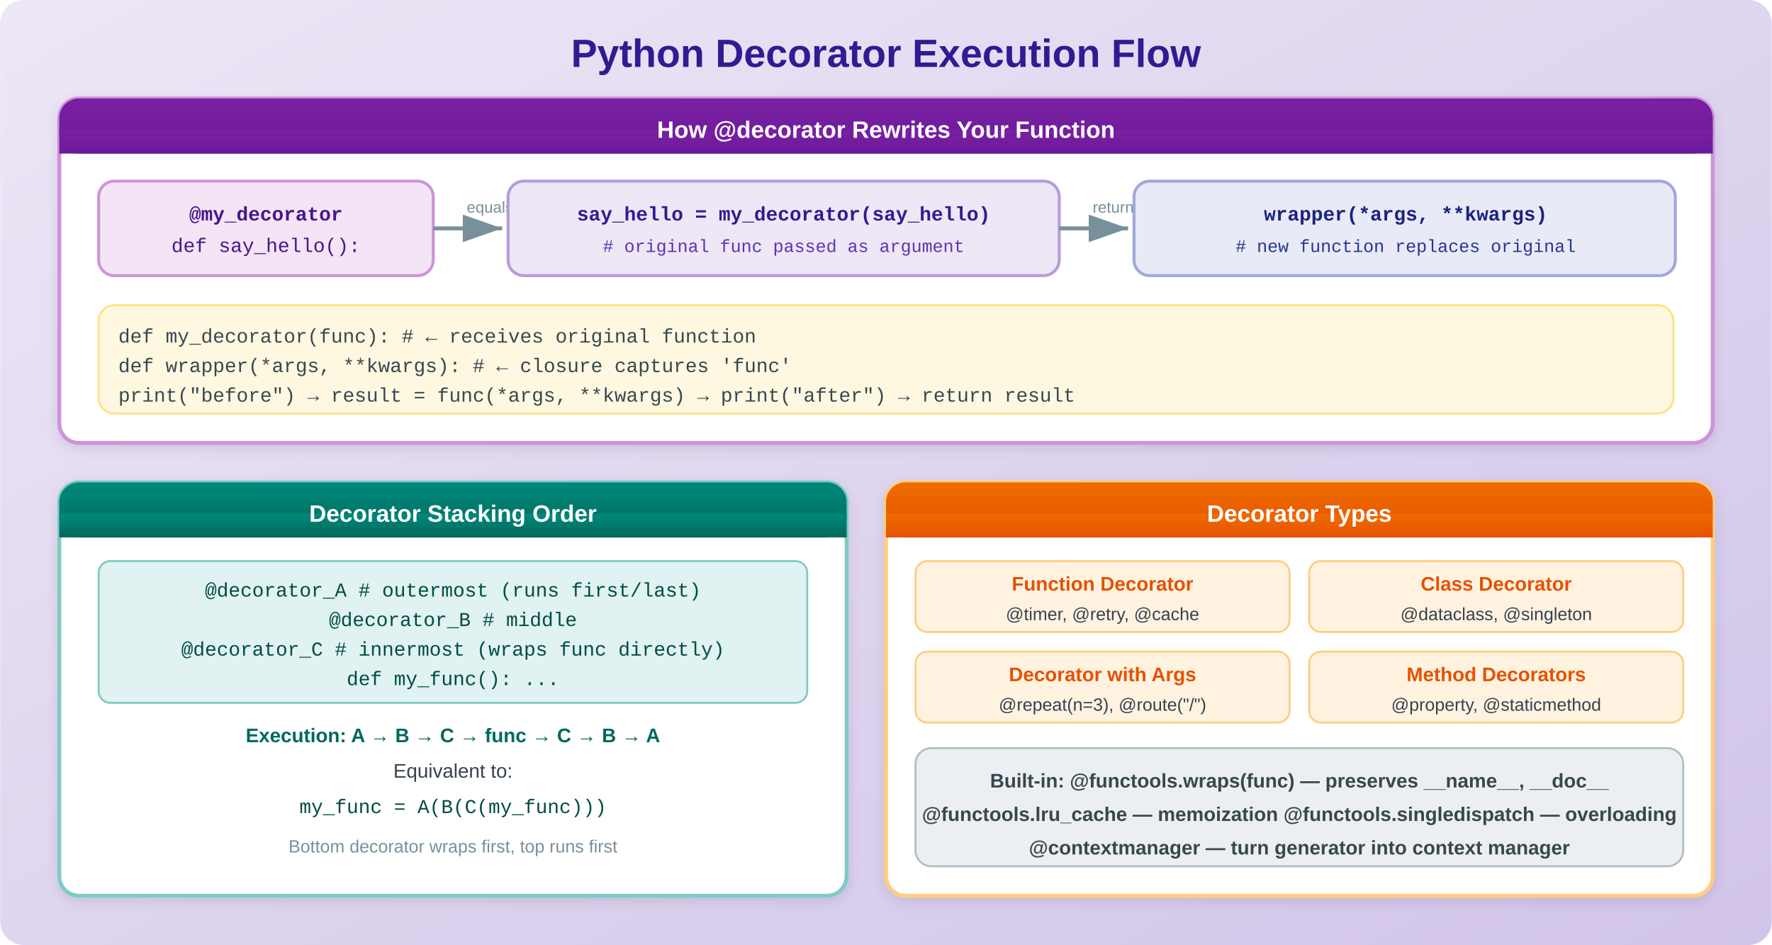

2.1 Basic Decorator
import functools

def timer(func):
@functools.wraps(func) # preserves __name__, __doc__
def wrapper(*args, **kwargs):
import time
start = time.perf_counter()
result = func(*args, **kwargs)
elapsed = time.perf_counter() - start
print(f'{func.__name__} took {elapsed:.4f}s')
return result
return wrapper

@timer
def slow_function():
import time; time.sleep(1)
return 'done'

2.2 Decorator with Arguments
def retry(max_attempts=3, exceptions=(Exception,)):
def decorator(func):
@functools.wraps(func)
def wrapper(*args, **kwargs):
for attempt in range(1, max_attempts + 1):
try:
return func(*args, **kwargs)
except exceptions as e:
if attempt == max_attempts:
raise
print(f'Attempt {attempt} failed: {e}')
return wrapper
return decorator

@retry(max_attempts=5, exceptions=(ConnectionError, TimeoutError))
async def fetch_data(url): ...

2.3 Class-Based Decorator
class CacheResult:
def __init__(self, func):
functools.update_wrapper(self, func)
self.func = func
self.cache = {}

def __call__(self, *args):
if args not in self.cache:
self.cache[args] = self.func(*args)
return self.cache[args]

@CacheResult
def fibonacci(n):
if n < 2: return n
return fibonacci(n-1) + fibonacci(n-2)

2.4 Built-in Decorators

Decorator | Module | Purpose
@property | builtins | Getter/setter/deleter for computed attributes
@staticmethod | builtins | Method with no self/cls parameter
@classmethod | builtins | Method receives class (cls) not instance
@functools.wraps | functools | Preserve wrapped function metadata
@functools.lru_cache | functools | Memoize with LRU eviction (maxsize)
@functools.cache | functools | Unbounded memoization (Python 3.9+)
@functools.singledispatch | functools | Function overloading by first arg type
@dataclasses.dataclass | dataclasses | Auto-generate __init__, __repr__, __eq__
@abc.abstractmethod | abc | Force subclass to implement method
@contextlib.contextmanager | contextlib | Turn generator into context manager
@typing.overload | typing | Declare multiple type signatures

3. Generators
Generators are functions that yield values one at a time, suspending state between yields. They are the foundation of lazy evaluation and memory-efficient data processing in Python.

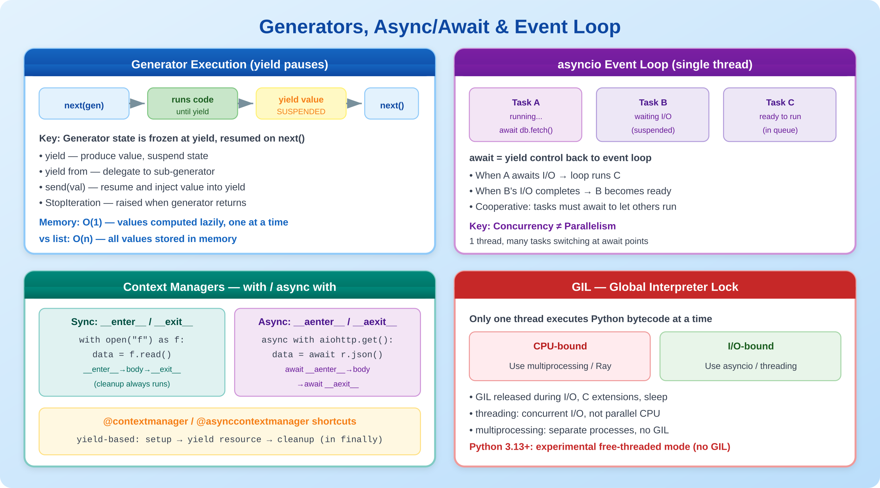

3.1 Generator Functions
def fibonacci():
a, b = 0, 1
while True:
yield a
a, b = b, a + b

fib = fibonacci()
print(next(fib)) # 0
print(next(fib)) # 1
print(next(fib)) # 1

# Take first 10
from itertools import islice
first_10 = list(islice(fibonacci(), 10))

3.2 Generator Expressions vs List Comprehensions
# List: creates all values in memory
squares_list = [x**2 for x in range(10_000_000)] # ~80MB

# Generator: computes one at a time
squares_gen = (x**2 for x in range(10_000_000)) # ~120 bytes

# Generators are single-use (exhaust after one pass)
total = sum(squares_gen) # works
total2 = sum(squares_gen) # 0! already exhausted

3.3 yield from (Delegation)
def flatten(nested):
for item in nested:
if isinstance(item, list):
yield from flatten(item) # delegate to sub-generator
else:
yield item

list(flatten([1, [2, [3, 4]], 5])) # [1, 2, 3, 4, 5]

3.4 send() and Coroutine-Style Generators
def accumulator():
total = 0
while True:
value = yield total # yield current total, receive new value
if value is None: break
total += value

acc = accumulator()
next(acc) # prime the generator (advance to first yield)
acc.send(10) # 10
acc.send(20) # 30
acc.send(5) # 35

4. Async / Await
Python’s async/await syntax enables writing concurrent I/O-bound code that scales to thousands of simultaneous connections on a single thread.

4.1 Coroutines & asyncio.run
import asyncio

async def fetch_data(url: str) -> dict:
async with aiohttp.ClientSession() as session:
async with session.get(url) as response:
return await response.json()

async def main():
# Run concurrently (not sequentially!)
results = await asyncio.gather(
fetch_data('https://api.example.com/users'),
fetch_data('https://api.example.com/items'),
fetch_data('https://api.example.com/orders'),
)
users, items, orders = results

asyncio.run(main()) # entry point

4.2 Tasks, gather, wait
async def main():
# Create tasks (start immediately)
task1 = asyncio.create_task(slow_operation(1))
task2 = asyncio.create_task(slow_operation(2))

# Wait for both
r1, r2 = await asyncio.gather(task1, task2)

# With timeout
try:
result = await asyncio.wait_for(slow_op(), timeout=5.0)
except asyncio.TimeoutError:
print('Operation timed out')

# Wait for first completed
done, pending = await asyncio.wait(
tasks, return_when=asyncio.FIRST_COMPLETED
)

4.3 Async Iteration & Comprehensions
# Async for loop
async for message in websocket:
process(message)

# Async comprehension
results = [await fetch(url) for url in urls]

# Async generator (see next chapter)
async for chunk in stream_data():
process(chunk)

4.4 Semaphores & Rate Limiting
sem = asyncio.Semaphore(10) # max 10 concurrent

async def rate_limited_fetch(url):
async with sem: # acquire slot
return await fetch(url)

# Process 1000 URLs with max 10 concurrent
results = await asyncio.gather(
*[rate_limited_fetch(url) for url in urls]
)

5. Context Managers
Context managers ensure resources are properly acquired and released using the with statement. They implement __enter__ and __exit__ (or use @contextmanager).

5.1 Class-Based Context Manager
class DatabaseConnection:
def __init__(self, url):
self.url = url
self.conn = None

def __enter__(self):
self.conn = connect(self.url)
return self.conn # bound to 'as' variable

def __exit__(self, exc_type, exc_val, exc_tb):
self.conn.close()
return False # False = re-raise exceptions

with DatabaseConnection('postgres://...') as conn:
conn.execute('SELECT ...')

5.2 Generator-Based (@contextmanager)
from contextlib import contextmanager

@contextmanager
def timer(label):
import time
start = time.perf_counter()
try:
yield # control passes to with-block
finally:
elapsed = time.perf_counter() - start
print(f'{label}: {elapsed:.4f}s')

with timer('database query'):
results = db.execute('SELECT ...')

5.3 Combining Multiple Contexts
# Python 3.10+ parenthesized context managers
with (
open('input.txt') as src,
open('output.txt', 'w') as dst,
timer('copy'),
):
dst.write(src.read())

# contextlib.ExitStack for dynamic number of contexts
from contextlib import ExitStack

with ExitStack() as stack:
files = [stack.enter_context(open(f)) for f in filenames]
# all files closed when block exits

6. Async Context Managers
Async context managers work with async with and implement __aenter__ and __aexit__. They are essential for managing async resources like DB pools, HTTP sessions, and WebSocket connections.

6.1 Class-Based Async Context Manager
class AsyncDBPool:
def __init__(self, url, size=10):
self.url = url
self.size = size

async def __aenter__(self):
self.pool = await asyncpg.create_pool(self.url, min_size=self.size)
return self.pool

async def __aexit__(self, exc_type, exc_val, exc_tb):
await self.pool.close()
return False

async with AsyncDBPool('postgres://...') as pool:
async with pool.acquire() as conn:
rows = await conn.fetch('SELECT * FROM users')

6.2 Generator-Based (@asynccontextmanager)
from contextlib import asynccontextmanager

@asynccontextmanager
async def http_session():
session = aiohttp.ClientSession()
try:
yield session
finally:
await session.close()

async with http_session() as session:
resp = await session.get('https://api.example.com')

7. Async Generators & Their Uses
Async generators combine generators (yield) with async/await, enabling lazy asynchronous iteration. They are ideal for streaming data, paginated APIs, and real-time event processing.

7.1 Basic Async Generator
async def stream_pages(url):
page = 1
while True:
data = await fetch(f'{url}?page={page}')
if not data['results']:
break
for item in data['results']:
yield item # async yield
page += 1

async for user in stream_pages('/api/users'):
process(user)

7.2 Async Generator for Real-Time Data
async def watch_events(redis_channel):
pubsub = redis.pubsub()
await pubsub.subscribe(redis_channel)
try:
async for message in pubsub.listen():
if message['type'] == 'message':
yield json.loads(message['data'])
finally:
await pubsub.unsubscribe(redis_channel)

# Server-Sent Events endpoint
async def sse_handler():
async for event in watch_events('notifications'):
yield f'data: {json.dumps(event)}\n\n'

7.3 Async Generator Cleanup
async def read_chunks(path, size=8192):
async with aiofiles.open(path, 'rb') as f:
while chunk := await f.read(size):
yield chunk
# file auto-closed when generator exits

# Force cleanup with aclose()
gen = read_chunks('large_file.bin')
async for chunk in gen:
if found_what_we_need(chunk):
await gen.aclose() # triggers cleanup
break

8. map, reduce & Functional Programming
Python supports functional programming patterns through built-in functions and the functools/itertools modules.

8.1 map, filter, reduce
# map — apply function to each element
names = ['alice', 'bob', 'charlie']
upper_names = list(map(str.upper, names)) # ['ALICE', 'BOB', 'CHARLIE']

# filter — keep elements where function returns True
evens = list(filter(lambda x: x % 2 == 0, range(10)))

# reduce — fold/accumulate to single value
from functools import reduce
product = reduce(lambda a, b: a * b, [1, 2, 3, 4, 5]) # 120

# Prefer comprehensions for readability
upper_names = [n.upper() for n in names] # clearer than map
evens = [x for x in range(10) if x % 2 == 0] # clearer than filter

8.2 itertools — Iterator Building Blocks

Function | Description | Example
chain(*iters) | Flatten multiple iterables | chain([1,2], [3,4]) → 1,2,3,4
islice(iter, n) | Slice an iterator lazily | islice(count(), 5) → 0,1,2,3,4
groupby(iter, key) | Group consecutive items | groupby('AABBC') → (A,[A,A]),(B,[B,B])...
product(A, B) | Cartesian product | product('AB','12') → A1,A2,B1,B2
permutations(iter, r) | All r-length orderings | permutations('ABC',2)
combinations(iter, r) | All r-length subsets | combinations('ABCD',2)
starmap(fn, iter) | map with unpacked args | starmap(pow, [(2,3),(3,2)]) → 8,9
tee(iter, n) | Clone iterator n times | a,b = tee(gen, 2)
accumulate(iter, fn) | Running totals | accumulate([1,2,3]) → 1,3,6
zip_longest(*iters) | Zip, fill missing with None | zip_longest('AB','xyz')

8.3 functools Highlights
from functools import partial, reduce, lru_cache, singledispatch

# partial — fix some arguments
int_from_hex = partial(int, base=16)
int_from_hex('ff') # 255

# singledispatch — function overloading
@singledispatch
def process(data):
raise TypeError(f'Unsupported: {type(data)}')

@process.register(str)
def _(data): return data.upper()

@process.register(list)
def _(data): return [process(x) for x in data]

9. Dunder (Magic) Methods
Dunder methods (double underscore) let your classes integrate with Python’s built-in operators, iteration, context management, and more. They are the backbone of Python’s data model.

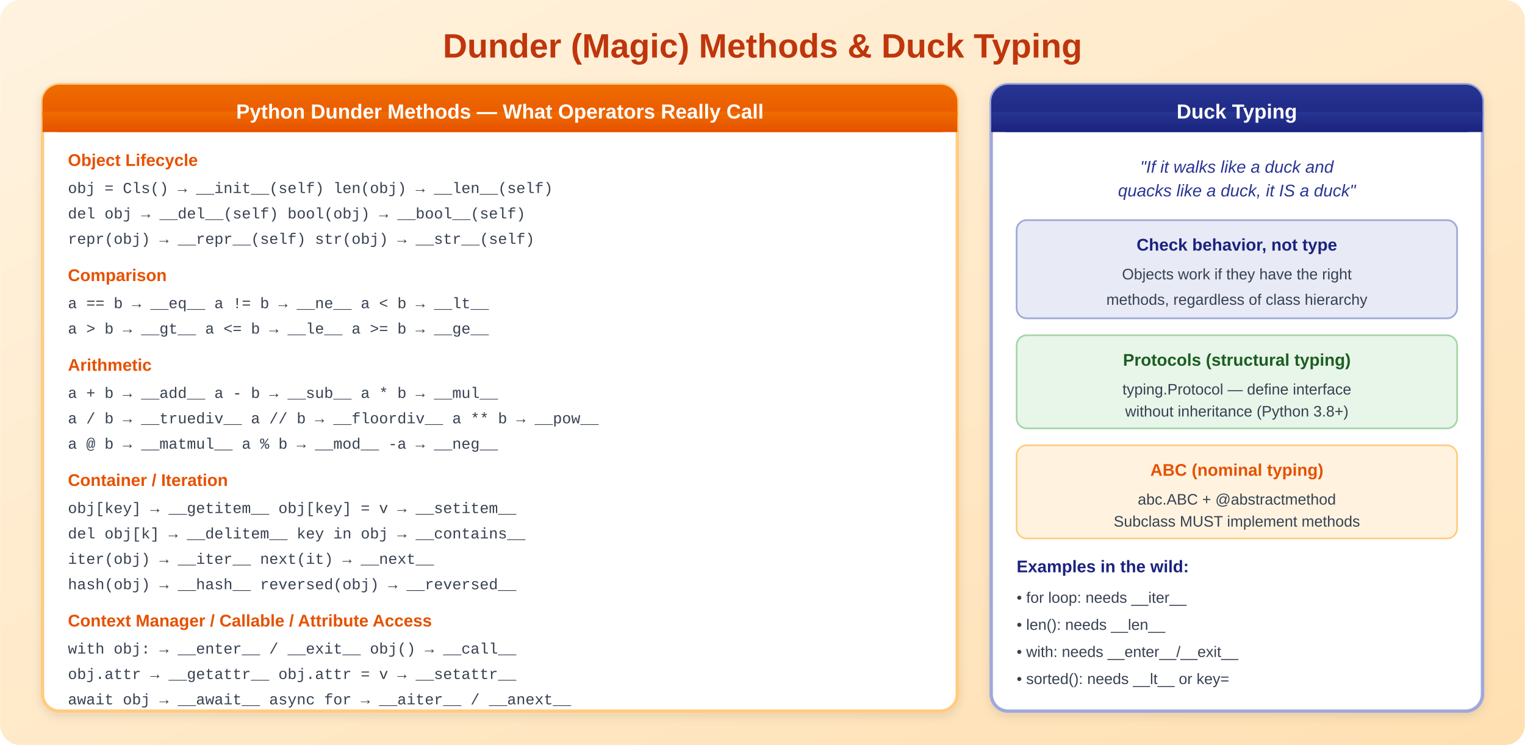

9.1 Making a Complete Custom Class
class Vector:
__slots__ = ('x', 'y') # memory-efficient

def __init__(self, x: float, y: float):
self.x = x
self.y = y

def __repr__(self): return f'Vector({self.x}, {self.y})'
def __str__(self): return f'({self.x}, {self.y})'
def __eq__(self, other): return self.x == other.x and self.y == other.y
def __hash__(self): return hash((self.x, self.y))
def __abs__(self): return (self.x**2 + self.y**2) ** 0.5
def __bool__(self): return bool(abs(self))
def __add__(self, other): return Vector(self.x+other.x, self.y+other.y)
def __mul__(self, scalar): return Vector(self.x*scalar, self.y*scalar)
def __rmul__(self, scalar): return self.__mul__(scalar)
def __iter__(self): yield self.x; yield self.y
def __getitem__(self, i): return (self.x, self.y)[i]
def __len__(self): return 2

9.2 Making Your Class a Container
class Registry:
def __init__(self):
self._items = {}

def __setitem__(self, key, value): self._items[key] = value
def __getitem__(self, key): return self._items[key]
def __delitem__(self, key): del self._items[key]
def __contains__(self, key): return key in self._items
def __len__(self): return len(self._items)
def __iter__(self): return iter(self._items)

reg = Registry()
reg['user1'] = User('Alice')
'user1' in reg # True
for key in reg: print(key)

10. Duck Typing & Protocols
Python uses duck typing: if an object has the right methods, it works regardless of its class. Python 3.8+ adds Protocols for structural subtyping that works with type checkers.

10.1 Duck Typing in Practice
def process_items(container):
"""Works with any iterable — list, tuple, set, generator..."""
for item in container: # needs __iter__
print(item)

# All of these work:
process_items([1, 2, 3])
process_items((1, 2, 3))
process_items({1, 2, 3})
process_items(range(1, 4))
process_items(x for x in [1, 2, 3]) # generator

10.2 Protocols (Structural Subtyping)
from typing import Protocol, runtime_checkable

@runtime_checkable
class Drawable(Protocol):
def draw(self, canvas: 'Canvas') -> None: ...
def bounding_box(self) -> tuple[int, int, int, int]: ...

class Circle: # no inheritance needed!
def draw(self, canvas): canvas.draw_circle(self)
def bounding_box(self): return (self.x-self.r, self.y-self.r,
self.x+self.r, self.y+self.r)

def render(shape: Drawable): # type-safe duck typing
shape.draw(canvas)

isinstance(Circle(), Drawable) # True (runtime_checkable)

10.3 Abstract Base Classes (ABCs)
from abc import ABC, abstractmethod

class Shape(ABC):
@abstractmethod
def area(self) -> float: ...

@abstractmethod
def perimeter(self) -> float: ...

def describe(self): # concrete method
return f'Area={self.area():.2f}, Perimeter={self.perimeter():.2f}'

class Circle(Shape):
def __init__(self, r): self.r = r
def area(self): return 3.14159 * self.r ** 2
def perimeter(self): return 2 * 3.14159 * self.r

11. Python Data Science & Ecosystem Libraries

Library | Category | Description & Key Use
NumPy | Numerical | N-dimensional arrays, linear algebra, FFT. Foundation for all scientific Python.
Pandas | Data Analysis | DataFrames for tabular data. read_csv, groupby, merge, pivot, time series.
Polars | Data Analysis | Blazing-fast DataFrames in Rust. Lazy evaluation, parallel execution. Pandas alternative.
Matplotlib | Visualization | Foundational plotting library. Line, bar, scatter, histogram, subplots.
Seaborn | Visualization | Statistical plots built on Matplotlib. Heatmaps, pair plots, violin plots.
Plotly | Visualization | Interactive plots for web. 3D, maps, dashboards. Works with Dash.
Dash | Web Dashboards | Build reactive web dashboards in pure Python. Built on Flask + React + Plotly.
Streamlit | Web Dashboards | Build ML demos and data apps with minimal code. Hot reload, widgets, caching.
Scikit-learn | ML | Classification, regression, clustering, preprocessing, model selection, pipelines.
PyTorch | Deep Learning | Dynamic computation graphs, GPU tensors, autograd, torchvision, torchaudio.
TensorFlow | Deep Learning | Production ML platform. Keras API, TF Serving, TF Lite for mobile/edge.
Ray | Distributed | Distributed computing framework. Ray Tune, Ray Serve, Ray Data for scaling Python.
Dask | Distributed | Parallel DataFrames/arrays. Scales pandas/NumPy workflows to clusters.
SQLAlchemy | Database | Python SQL toolkit and ORM. Async support. Used by FastAPI, Flask.
Pydantic | Validation | Data validation using type hints. JSON parsing. Settings management.
httpx | HTTP Client | Async/sync HTTP client. Replaces requests for modern Python.
pytest | Testing | Modern test framework. Fixtures, parametrize, plugins, async support.
Celery | Task Queue | Distributed task processing. Redis/RabbitMQ backends. Periodic tasks.
Typer | CLI | Build CLI apps with type hints. Auto --help, completion. Based on Click.
Rich | Terminal | Beautiful terminal output. Tables, progress bars, syntax highlighting, logging.

11.1 NumPy Essentials
import numpy as np

a = np.array([1, 2, 3, 4])
m = np.zeros((3, 4)) # 3x4 matrix of zeros
r = np.random.randn(1000) # 1000 random normals

# Vectorized operations (100x faster than loops)
result = a * 2 + 1 # element-wise
dot = np.dot(a, a) # dot product

# Broadcasting
matrix = np.ones((3, 4))
matrix + np.array([1, 2, 3, 4]) # adds to each row

# Indexing
m[m > 0.5] # boolean indexing
m[:, 1:3] # slice columns

11.2 Pandas Essentials
import pandas as pd

df = pd.read_csv('data.csv')

# Core operations
df.head() # first 5 rows
df.describe() # statistics
df.groupby('category')['price'].mean()
df.merge(other_df, on='id', how='left')
df.pivot_table(values='sales', index='region', columns='quarter')

# Method chaining
result = (df
.query('age > 25')
.assign(income_bracket=lambda x: pd.cut(x.income, bins=5))
.groupby('income_bracket')
.agg({'spending': ['mean', 'sum']})
)

11.3 Polars (Pandas Alternative)
import polars as pl

df = pl.read_csv('data.csv')

# Lazy evaluation (query optimization)
result = (
df.lazy()
.filter(pl.col('age') > 25)
.group_by('category')
.agg(pl.col('price').mean().alias('avg_price'))
.sort('avg_price', descending=True)
.collect() # execute optimized query plan
)

11.4 Streamlit & Dash
# ── Streamlit (data app in 10 lines) ──
import streamlit as st
st.title('Sales Dashboard')
data = st.file_uploader('Upload CSV')
if data:
df = pd.read_csv(data)
st.dataframe(df)
st.line_chart(df['revenue'])
metric = st.selectbox('Metric', df.columns)
st.bar_chart(df[metric])

# ── Dash (reactive web dashboard) ──
from dash import Dash, dcc, html, Input, Output
app = Dash()
app.layout = html.Div([
dcc.Dropdown(id='col', options=columns),
dcc.Graph(id='chart'),
])
@app.callback(Output('chart','figure'), Input('col','value'))
def update(col): return px.histogram(df, x=col)

11.5 Ray (Distributed Computing)
import ray
ray.init()

@ray.remote
def process_shard(shard):
return heavy_computation(shard)

# Distribute across all cores / cluster nodes
futures = [process_shard.remote(s) for s in shards]
results = ray.get(futures) # collect results

12. Metaprogramming
Metaprogramming means writing code that generates or modifies other code at runtime. Python’s dynamic nature makes it exceptionally powerful for metaprogramming.

12.1 Metaclasses
class SingletonMeta(type):
_instances = {}
def __call__(cls, *args, **kwargs):
if cls not in cls._instances:
cls._instances[cls] = super().__call__(*args, **kwargs)
return cls._instances[cls]

class Database(metaclass=SingletonMeta):
def __init__(self):
self.connection = create_connection()

# Both are the same object
db1 = Database()
db2 = Database()
assert db1 is db2 # True

12.2 __init_subclass__
A simpler alternative to metaclasses for customizing subclass creation (Python 3.6+).
class Plugin:
_registry = {}

def __init_subclass__(cls, name=None, **kwargs):
super().__init_subclass__(**kwargs)
cls._registry[name or cls.__name__] = cls

class JSONPlugin(Plugin, name='json'):
def parse(self, data): return json.loads(data)

class XMLPlugin(Plugin, name='xml'):
def parse(self, data): return xml_parse(data)

Plugin._registry # {'json': JSONPlugin, 'xml': XMLPlugin}

12.3 Descriptors
class Validated:
def __init__(self, validator):
self.validator = validator

def __set_name__(self, owner, name):
self.name = name

def __get__(self, obj, objtype=None):
return obj.__dict__.get(self.name)

def __set__(self, obj, value):
if not self.validator(value):
raise ValueError(f'Invalid {self.name}: {value!r}')
obj.__dict__[self.name] = value

class User:
name = Validated(lambda x: isinstance(x, str) and len(x) > 0)
age = Validated(lambda x: isinstance(x, int) and 0 <= x <= 150)

12.4 Dynamic Class Creation
# type() as a class factory
MyClass = type('MyClass', (Base,), {
'method': lambda self: 'hello',
'x': 42,
})

# __class_getitem__ for generic subscript syntax
class Matrix:
def __class_getitem__(cls, params):
rows, cols = params
return type(f'Matrix{rows}x{cols}', (cls,), {
'rows': rows, 'cols': cols
})

M = Matrix[3, 4] # creates Matrix3x4 class

13. Testing

13.1 pytest Fundamentals
import pytest

def test_addition():
assert 1 + 1 == 2

def test_exception():
with pytest.raises(ValueError, match='invalid'):
int('not_a_number')

# Parametrize — run test with multiple inputs
@pytest.mark.parametrize('input,expected', [
('hello', 5), ('', 0), ('python', 6),
])
def test_string_length(input, expected):
assert len(input) == expected

13.2 Fixtures
@pytest.fixture
def db_session():
session = create_test_session()
yield session
session.rollback()
session.close()

@pytest.fixture
def sample_user(db_session):
user = User(name='Alice', email='a@b.com')
db_session.add(user)
db_session.commit()
return user

def test_get_user(db_session, sample_user):
found = db_session.query(User).get(sample_user.id)
assert found.name == 'Alice'

13.3 Mocking
from unittest.mock import patch, MagicMock, AsyncMock

@patch('app.services.email.send')
def test_registration(mock_send):
register_user('alice@example.com')
mock_send.assert_called_once_with('alice@example.com', subject='Welcome!')

# Async mocking
@patch('app.client.fetch', new_callable=AsyncMock)
async def test_fetch(mock_fetch):
mock_fetch.return_value = {'status': 'ok'}
result = await get_status()
assert result == 'ok'

13.4 Async Testing
import pytest

@pytest.mark.anyio # or @pytest.mark.asyncio
async def test_async_endpoint():
async with AsyncClient(app=app, base_url='http://test') as client:
response = await client.get('/users')
assert response.status_code == 200
assert len(response.json()) > 0

14. Async I/O Libraries

Library | Category | Description
asyncio | Stdlib | Event loop, tasks, futures, queues, synchronization primitives
aiohttp | HTTP | Async HTTP client + server. WebSocket support.
httpx | HTTP | Modern async/sync HTTP client. Replaces requests + aiohttp client.
aiofiles | File I/O | Async file read/write operations.
asyncpg | Database | Ultra-fast async PostgreSQL driver (fastest Python PG driver).
aiomysql | Database | Async MySQL driver based on PyMySQL.
motor | Database | Async MongoDB driver (official).
aioredis / redis-py | Cache | Async Redis client for caching, pub/sub, queues.
aiokafka | Messaging | Async Apache Kafka producer/consumer.
websockets | WebSocket | High-level async WebSocket client and server.
uvloop | Performance | Drop-in replacement for asyncio event loop. 2-4x faster.
anyio | Compatibility | Structured concurrency. Works with asyncio, trio, curio.
trio | Alternative | Alternative async library with stricter structured concurrency.

14.1 Common Patterns
# Producer-consumer with asyncio.Queue
async def producer(queue):
for item in data:
await queue.put(item)
await queue.put(None) # sentinel

async def consumer(queue):
while (item := await queue.get()) is not None:
await process(item)

queue = asyncio.Queue(maxsize=100)
await asyncio.gather(producer(queue), consumer(queue))

# Connection pooling
pool = await asyncpg.create_pool(DATABASE_URL, min_size=5, max_size=20)
async with pool.acquire() as conn:
rows = await conn.fetch('SELECT * FROM users WHERE active = $1', True)

15. The GIL (Global Interpreter Lock)
The GIL is a mutex in CPython that allows only one thread to execute Python bytecode at a time. Understanding it is critical for writing performant concurrent Python.

15.1 Why the GIL Exists
- CPython’s memory management (reference counting) is not thread-safe
- The GIL simplifies C extension development
- It protects internal interpreter state from corruption
- Removing it was historically too expensive (slower single-threaded performance)

15.2 Impact on Concurrency

Workload | threading | multiprocessing | asyncio
CPU-bound (math, ML) | No speedup (GIL blocks) | Full parallelism | No speedup
I/O-bound (network, disk) | Good (GIL released during I/O) | Overkill, high overhead | Best choice
Mixed CPU + I/O | Limited | Good with IPC overhead | Good for I/O parts

15.3 Workarounds
# 1. multiprocessing — true parallelism
from multiprocessing import Pool
with Pool(8) as pool:
results = pool.map(cpu_intensive_fn, data_chunks)

# 2. concurrent.futures — unified interface
from concurrent.futures import ProcessPoolExecutor, ThreadPoolExecutor
with ProcessPoolExecutor(max_workers=8) as executor:
futures = [executor.submit(task, arg) for arg in args]
results = [f.result() for f in futures]

# 3. C extensions release GIL (NumPy, Pandas, scikit-learn)
# NumPy operations run in C and release the GIL automatically

# 4. Python 3.13+ free-threaded mode (experimental)
# python3.13t --disable-gil script.py

15.4 Python 3.13+ Free-Threaded Mode
PEP 703 introduced an experimental build of CPython without the GIL. This enables true multi-threaded parallelism for CPU-bound Python code. It requires recompiling Python and some C extensions may need updates.
# Check if GIL is disabled
import sys
print(sys._is_gil_enabled()) # False in free-threaded build

# Now threading gives real parallelism for CPU-bound work
import threading
threads = [threading.Thread(target=cpu_task, args=(chunk,))
for chunk in chunks]
for t in threads: t.start()
for t in threads: t.join() # actually runs in parallel!

16. Quick Reference Cheatsheet

Concept | Key Points
Comprehensions | [expr for x in iter if cond] — list, dict, set, generator variants
Walrus := | Assign in expression: if (n := len(x)) > 10: use(n)
match/case | Structural pattern matching with destructuring (3.10+)
Decorators | @deco = func = deco(func). Use @wraps. Stack: bottom wraps first.
Generators | yield suspends state. Memory O(1). yield from delegates. send() injects.
async/await | Cooperative concurrency. asyncio.gather for parallel I/O. Single thread.
Context Manager | with: __enter__/__exit__. @contextmanager for generator-based.
Async CM | async with: __aenter__/__aexit__. @asynccontextmanager.
Async Generators | async def + yield. async for to consume. aclose() for cleanup.
map/filter/reduce | Functional tools. Prefer comprehensions. itertools for advanced.
Dunder Methods | __init__, __repr__, __add__, __iter__, __getitem__, __call__, ...
Duck Typing | Check behavior, not type. Protocol for structural typing.
Metaclasses | type subclass. __init_subclass__ is simpler. Descriptors for attributes.
Testing | pytest + fixtures + parametrize + mock. anyio for async tests.
GIL | 1 thread runs bytecode. asyncio for I/O. multiprocessing for CPU. 3.13+ no-GIL.

End of document.

